Answers:

1.(a)

gcd(288, 120)

= gcd(288 mod 120, 120)

= gcd(48, 120)

= gcd(120 mod 48, 48)

= gcd(48, 24)

= 24

(b)

lcm(-91, 52)

= |-91 \* 52| / gcd(-91,52)

gcd(-91, 52)

= gcd(39, 52)

= gcd(13, 53)

= 13

hence:

lcm(-91, 52)

= |-91 \* 52| / 13

= 364

(c)

If n = 0, n + 1 = 1, 1|0, 1|1, so gcd(0, 1) = 1

If n ≠ 0:

gcd(n, n+1)

= gcd(n+1-n, n)

= gcd(1, n)

= 1

hence

gcd(n, n + 1) = 1 for n ∈ N

2. (a)

Pow(∅) = {∅}

Pow(Pow(∅)) = {∅, {∅}}

card(Pow(Pow(∅))) = 2

(b)

A ∩ (B ⊕ C)

= A ∩ ((B ∩ CC)) ∪ (C ∩ BC))

= (A ∩ (B ∩ CC)) ∪ (A ∩ (C ∩ BC))

= ((∅ ∩ B) ∪ (A ∩ (B ∩ CC))) ∪ ((∅ ∩ C) ∪ (A ∩ (C ∩ BC)))

= (((A ∩ AC) ∩ B) ∪ (A ∩ (B ∩ CC))) ∪ (((A ∩ AC) ∩ C) ∪ (A ∩ (C ∩ BC)))

= (((A ∩ B) ∩ AC) ∪ ((A ∩ B) ∩ CC)) ∪ (((A ∩ C) ∩ AC) ∪ ((A ∩ C) ∩ BC))

= ((A ∩ B) ∩ (AC ∪ CC)) ∪ ((A ∩ C) ∩ (AC ∪ BC))

= ((A ∩ B) \ (A∩ C)) ∪ ((A ∩ C) \ (A∩ B))

= (A ∩ B) ⊕ (A ∩ C)

(c)

B ∩ C:

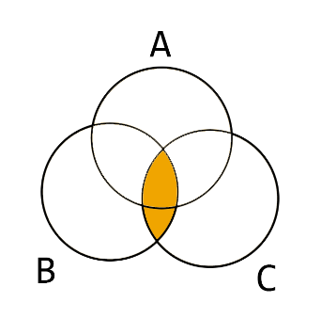

(B ∩ C) \ A:

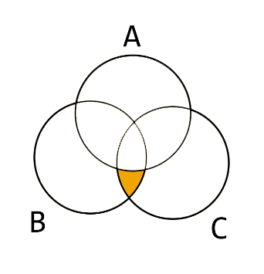

A \ (B ∩ C):

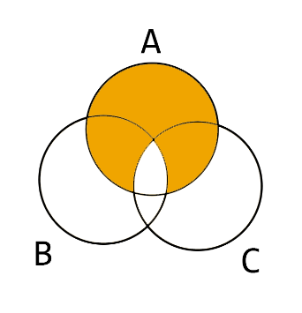

A ⊕ (B ∩ C) = ((B ∩ C) \ A) ∪ (A \ (B ∩ C)):

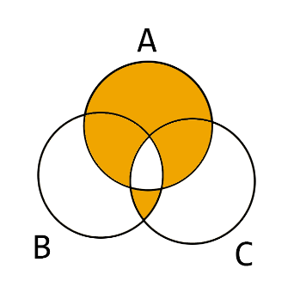

A ⊕ B:

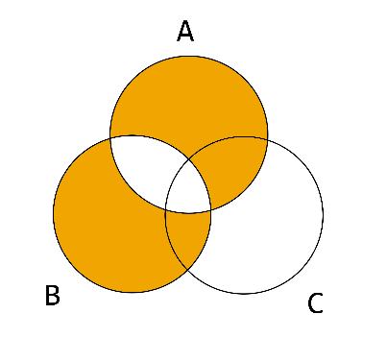

A ⊕ C:

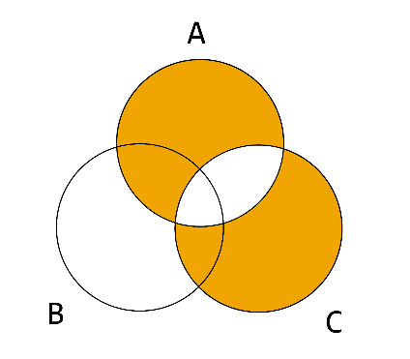

(A ⊕ B) ∩ (A ⊕ C):

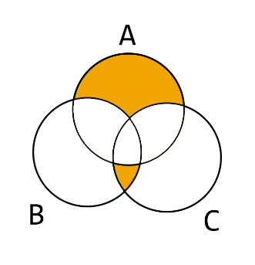

Hence, (A ⊕ (B ∩ C)) \ ((A ⊕ B) ∩ (A ⊕ C)):

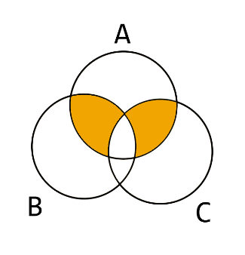

The same Venn diagram above can also be written as:

(A ∩ B) ⊕ (A ∩ C)

Hence

(A ⊕ (B ∩ C)) \ ((A ⊕ B) ∩ (A ⊕ C)) = (A ∩ B) ⊕ (A ∩ C).

if (A ∩ B) ⊕ (A ∩ C) ≠ ∅, (A ⊕ (B ∩ C)) ≠ ((A ⊕ B) ∩ (A ⊕ C)).

For instance, if A = {1, 2, 3, 4}, B = {3, 4, 5, 6}, C = {2, 3, 6, 7}, then (A ⊕ (B ∩ C)) = {1, 2, 4, 6}, and ((A ⊕ B) ∩ (A ⊕ C)) = {1, 6},

Hence, in this case, (A ⊕ (B ∩ C)) ≠ ((A ⊕ B) ∩ (A ⊕ C))

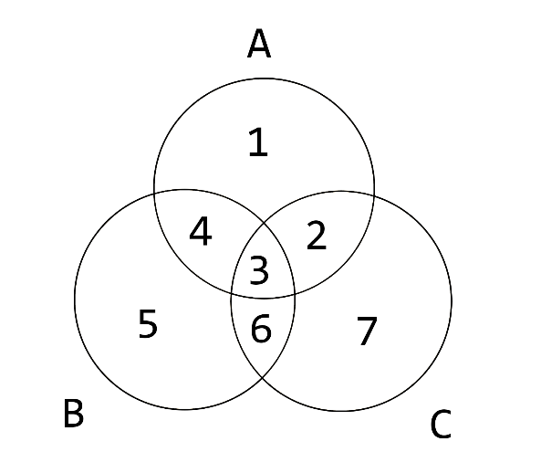

3.

(a) Σ≤3 = {λ, a, aa, aaa, aab, ab, aba, abb, b, ba, baa, bab, bb, bba, bbb}

(b) Σ≤3 = {λ, a, b, aa, ab, ba, bb, aaa, aab, aba, abb, baa, bab, bba, bbb}

4.

(a)

f: f(a) = 0, f(b) = 0, f(c) = 0

f: f(a) = 0, f(b) = 0, f(c) = 1

f: f(a) = 0, f(b) = 1, f(c) = 0

f: f(a) = 0, f(b) = 1, f(c) = 1

f: f(a) = 1, f(b) = 0, f(c) = 0

f: f(a) = 1, f(b) = 0, f(c) = 1

f: f(a) = 1, f(b) = 1, f(c) = 0

f: f(a) = 1, f(b) = 1, f(c) = 1

(b)

(i) For each b ∈ B, we can find m members from A to establish functions. Hence number of functions = nm

(ii) Relations between A and B: R = A x B. Hence |R| = |A| x |B| = m x n

(c)

Pow(a, b, c) = {∅, a, b, c, ab, ac, bc, abc}

|Pow(a, b, c)| = 2|{a, b, c}| = 23 = 8

Number of f : {a, b, c} → {0, 1} = nm = 23 = 8

|Pow(a, b, c)| = Number of f : {a, b, c} → {0, 1}

To explain this, for f : {a, b, c} → {0, 1}, each possible function corresponds to some subset A ⊆ Pow(a, b, c), in the way:

for each element x ∈ A, f(x) C:\Users\seren\Desktop\Asset 1@300x-8.png 1, and

for each element y ∈ (Pow(a, b, c) \ A), f(y) C:\Users\seren\Desktop\Asset 1@300x-8.png 0

Hence

the number of all possible functions = card(Pow(a, b, c)) = 8

5.

(a)

(i) (abab, baba)

(v) (λ, bbb)

(b)

(R) In the case of (a, a) ∈ R, for any v ∈ Σ\*, av = av. Hence R is reflexive.

(S) For (a, b) ∈ R, for all v ∈ Σ\*,

(av ∈ L ∧ bv ∈ L) ⊕ (av ∉ L ∧ bv ∉ L) = true.

Since the Boolean " ∧" is commutative:

(bv ∈ L ∧ av ∈ L) ⊕ (bv ∉ L ∧ av ∉ L) = true

Hence in the case of (b, a), for all v ∈ Σ\*, R is symmetric.

(T) Let (a, b) ∈ R and (b, c) ∈ R, hence for all v ∈ Σ\*, v' ∈ Σ\*:

(av ∈ L ∧ bv ∈ L) ⊕ (av ∉ L ∧ bv ∉ L) = true, (bv` ∈ L ∧ cv` ∈ L) ⊕ (bv` ∉ L ∧ cv` ∉ L) = true.

With av ∈ L, bv ∈ L, since v and v' are arbitrary, bv` ∈ L, cv` ∈ L:

Since v and v' are arbitrary, av' ∈ L, bv' ∈ L, bv ∈ L, cv ∈ L also establish, so av ∈ L, cv ∈ L, a R c.

With av ∉ L, bv ∉ L, since v and v' are arbitrary, bv` ∉ L and cv` ∉ L:

Since v and v' are arbitrary, av' ∉ L, bv' ∉ L, bv ∉ L and cv ∉ L also establish, so (av ∉ L, cv ∉ L).

Hence R is transitive.

Concluding from (R), (S), (T), R is an equivalence relation.

(c)

X = {w ∈ Σ\*: 3|length(w)}

Y = {w ∈ Σ\*: 3|(length(w) + 1)}

Z = {w ∈ Σ\*: 3|(length(w) + 2)}